**Digital Logic Design**



**Member Name:**

**Roll No :**

**DEPARTMENT**: BSIT

**BATCH**: 09

**COURSE**: Digital Logic Design

**“KNOWLEDGE UNIT OF SYSTEMS AND TECHNOLOGY, UMT, SIALKOT”**

**Door Sensor**

**Introduction:**

* A car Door Senser using Infrared (IR) sensor and an OR gate is an Electronic system designed to detect, when door is not close. If any door opens, sensor detect it and buzzer produce sound. It safes car by thief.

**Apparatus:**

Following are the apparatus used in Car Door Sensor.

* OR Gate (4- inputs)
* Infrared (IR) Sensor
* Breadboard
* Uno Device
* Buzzer
* Battery(9v)
* Potential detector

**Working:**

By using Uno Device, we provide high voltage and low voltage. Using male to male wire we connect IR sensor and OR gate (which have 4 inputs) with Uno providing **(5v)** which is high voltage **and low voltage.** We provide separate voltages to IR sensor and OR gatebecause using this sensor and gate working accurately. We connect outputs of four IR sensors with 2,3,4,5 pins of OR gate. And 6th pin of OR gate which is output is connected with positive terminal of potential detector and negative terminal of potential detector is connected with ground of Uno. Potential detector provide complete current to buzzer. 5v is not enough for buzzer so, we used potential detector. It detect 9v current by battery and provide it to buzzer.

When we provide 5v current to IR sensor and OR gate . the sensors work start. When door of car is open, the sensor detect it and sound is produce by buzzer. When we place our hand above the sensors it denoted door of car is closed, so sound is not produce by buzzer.

**Truth table:**

|  |  |  |  |  |
| --- | --- | --- | --- | --- |
| **(Sensor)1** | **(Sensor)2** | **(Sensor)3** | **(Sensor)4** | **Output**  **(S1+S2+S3+S4)** |
| 0 | 0 | 0 | 0 | 0 |
| 0 | 0 | 0 | 1 | 1 |
| 0 | 0 | 1 | 0 | 1 |
| 0 | 0 | 1 | 1 | 1 |
| 0 | 1 | 0 | 0 | 1 |
| 0 | 1 | 0 | 1 | 1 |
| 0 | 1 | 1 | 0 | 1 |
| 0 | 1 | 1 | 1 | 1 |
| 1 | 0 | 0 | 0 | 1 |
| 1 | 0 | 0 | 1 | 1 |
| 1 | 0 | 1 | 0 | 1 |
| 1 | 0 | 1 | 1 | 1 |
| 1 | 1 | 0 | 0 | 1 |
| 1 | 1 | 0 | 1 | 1 |
| 1 | 1 | 1 | 0 | 1 |
| 1 | 1 | 1 | 1 | 1 |

**K-Map:**

|  |  |  |  |  |
| --- | --- | --- | --- | --- |
|  | **00** | **01** | **11** | **10** |
| **00** | 0 | 1 | 1 | 1 |
| **01** | 1 | 1 | 1 | 1 |
| **11** | 1 | 1 | 1 | 1 |
| **10** | 1 | 1 | 1 | 1 |

**Equation:**

= S2+ S1+ S4+ S3

= S1+ S2+ S3+ S4

**Circuit Diagram:**

**Case:01**

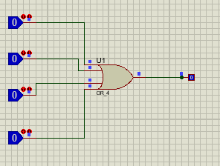

**Case:02**

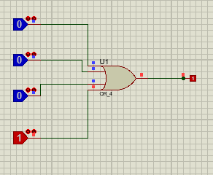

**Case:03**

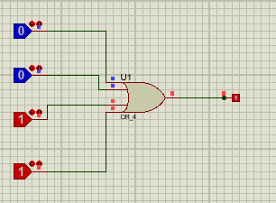

**Case:04**

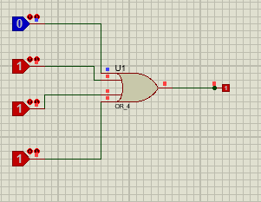

**Case:05**

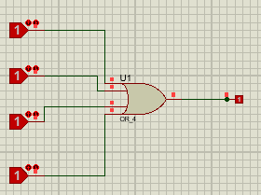

**Project Image:**

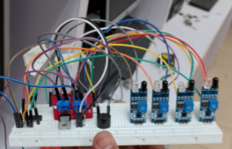

**Benefits:**

* IR sensors provide a non-contact method of detection, making them suitable for hygiene-sensitive environments.
* They are reliable for detecting motion and presence.
* IR sensors are generally affordable and easy to integrate into electronic systems.

By combining IR sensors with an OR gate, a system can be created that effectively detects movement or presence through a doorway, ensuring responsiveness and functionality in various applications. And also detect the car’s door is close or open.

**THE END**